
Denosumab

b

Denosumab

This is a treatment which works by attaching itself to bone and slows down the rate of bone change. In the bone there are two types of bone cells: osteoclasts, which break down old bone and osteoblasts which build up new bone. This treatment helps to ensure the balance of these cells is correct and bone stays healthy.

Some types of cancer can increase the rate of bone change. This can cause a number of problems, such as

- bone pain
- fractures
- release of too much calcium into the blood stream (this is called tumour induced hypercalcaemia)

Your treatment
Denosumab is given as an injection just below the skin (subcutaneously).

This is initially given every 4-6 weeks. Your doctor or nurse clinician may discuss reducing this to 3 monthly.

Prior to starting denosumab you will need to have your vitamin D level checked with a blood test. If this is low you will be prescribed a course of vitamin D supplements.
You will also be given calcium supplements to take alongside your Denosumab.

You will have a routine blood test before the start of each cycle of treatment.
Occasionally we may not be able to go ahead with your treatment until your blood counts are back to a safe level. If this happens, your chemotherapy may be delayed a week.

This treatment can have serious or possibly life-threatening side effects. It is very important that you report side effects straight away.
Don’t delay, if you feel unwell, please ring The Christie Hotline on 0161 446 3658. The lines are open 24 hours a day.

Possible side effects
This treatment can cause many different side effects. Some are more likely to occur than others. Everyone is different and not everyone gets all the side effects. Most side effects are usually temporary, but in some rare cases they can be life-threatening. It is important to tell your hospital doctor or nurse about any side effects so they can be monitored and, where possible, treated.

Common side effects (more than 1 in 10)

- Flu-like symptoms
Denosumab may cause flu like symptoms such as fever, fatigue, weakness, drowsiness, headache, chills and aches in your muscles, joints and bones. In most cases you do not need any specific treatment and the symptoms should improve after a short time. However, taking paracetamol can be helpful.

- Low calcium levels
You will have regular blood tests to check your calcium levels and you will be given a calcium and vitamin D supplement.

- Breathlessness
If you develop any problems with breathing, please ring The Christie Hotline on
0161 446 3658 immediately.

Uncommon side effects (less than 1 in 10)

- Skin reactions
Some people may develop a rash and itching. If this happens, please tell your doctor or nurse.

Rare side effects (less than 1 in 100)

- Osteo-necrosis of the jaw
Very occasionally, a rare side effect can occur with denosumab, when there is necrosis (a loss of jaw bone) or a breakdown of the jaw bone. It is called osteonecrosis of the jaw and can be a serious condition. Some of the symptoms are:

- pain, swelling or infection of the gums
- loosening of the teeth
- poor healing of the gums
- numbness or feeling of heaviness in the jaw

If you have any of the symptoms listed above or any other dental problems tell your Christie doctor immediately

What you should do…..
We strongly recommend that you have a dental examination with your dentist before you start treatment with denosumab. If you need any dental work, this must be done before you start this treatment with denosumab. People who wear dentures should make sure their dentures fit properly before starting treatment. Tell your doctor or dentist if you are a smoker.

If you need any dental treatment while taking denosumab.
While you are having treatment with denosumab you should try to avoid invasive dental procedures such as having teeth removed. If you do have to have teeth removed while you are having treatment with denosumab or soon after finishing treatment with denosumab, it is important to discuss this with your Christie doctor first. He or she may be able to refer you to an oral surgeon at the hospital rather than to your local dentist.

Dental health
Brush your teeth regularly and try to keep your mouth clean and healthy at all times. You can continue to see your dentist for your normal, regular check-ups and cleaning (but not treatment). You can also see your dental hygienist. Show them this leaflet, as it is important that the dentist and dental hygienist know that you are taking denosumab.

- Increased risk of infection
You may be more vulnerable to infection. If you develop any symptoms of infection such as urinary symptoms, an ear infection, respiratory tract infection, cellulitis or any other sites of infection, please contact The Christie Hotline for advice immediately.

- Clouding of the eye (cataracts)
If you notice any visual changes, please tell your doctor or nurse.

Late side effects
Some side effects may become evident only after a number of years. In reaching any decision with you about treatment, the potential benefit you receive from treatment will be weighed against the risks of serious long term side effects to the heart, lungs, kidneys and bone marrow. With some drugs there is also a small but definite risk of developing another cancer. If any of these problems specifically applies to you, the doctor will discuss these with you and note this on your consent form.

Contacts

If you have any general questions or concerns about your treatment, please ring the area where you are having treatment:

- Administration enquiries 0161 918 7606/7610
- Chemotherapy nurse: 0161 918 7171
- Clinical trials unit 0161 918 7663
- Breast care nurses 0161 446 3996

For advice ring The Christie Hotline on 0161 446 3658 (24 hours)

Your consultant is: .....................................................................

Your hospital number is: ...........................................................

Your key worker is: ....................................................................

If you need information in a different format, such as easy read, large print, BSL, braille, email, SMS text or other communication support, please tell your ward or clinic nurse.

We try to ensure that all our information given to patients is accurate, balanced and based on the most up-to-date scientific evidence. If you would like to have details about the sources used please contact patient.information@christie.nhs.uk

©2017 The Christie NHS Foundation Trust. This document may be copied for use within the NHS only on the condition that The Christie NHS Foundation Trust is acknowledged as the creator.

For information about The Christie and our services, please visit www.christie.nhs.uk or visit the cancer information centres at Withington, Oldham or Salford.

Contact The Christie Hotline for urgent support and specialist advice

The Christie Hotline:
0161 446 3658

Open 24 hours a day, 7 days a week

The Christie NHS Foundation Trust
Wilmslow Road
Withington
Manchester M20 4BX
Tel: 0161 446 3000
www.christie.nhs.uk

The Christie Patient Information Service
July 2017 - Review July 2020

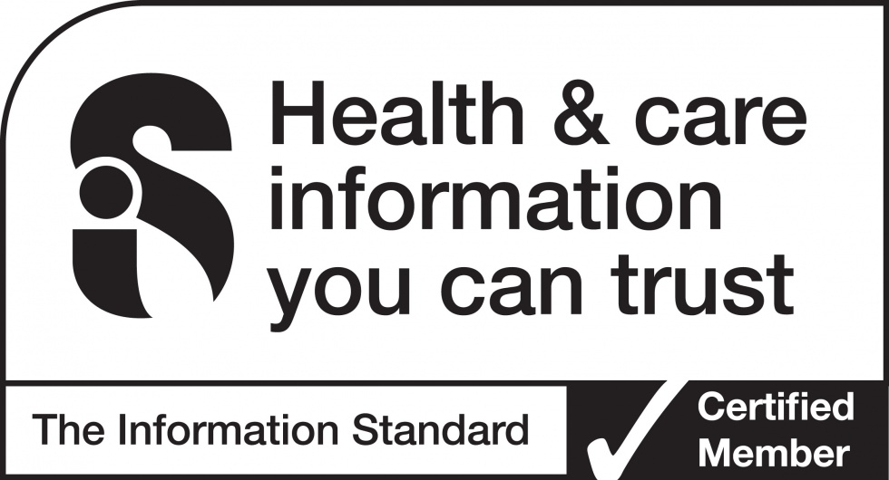

CHR/CT/1032/16.06.14 Version 2

