
Kadcyla (Trastuzumab emtansine)

b

Kadcyla (Trastuzumab emtansine)

This leaflet is offered as a guide to you and your family. The possible benefits of treatment vary; for some people chemotherapy may reduce the risk of the cancer coming back, for others it may control the cancer and its symptoms. Chemotherapy is the most commonly prescribed anti-cancer treatment but other types of treatment are also used. Your doctor will explain to you whether you will receive chemotherapy or another type of treatment, or a combination of both. Your doctor or nurse will be happy to answer any questions you have about your treatment. You will find it useful to refer to the booklet Chemotherapy, a guide which gives general information on chemotherapy and side effects.

Kadcyla is made up of two parts that are combined together:

- Trastuzumab (Herceptin) is a monoclonal antibody (targeted therapy)
- Emtansine (TDM1) is an anti-cancer drug, sometimes referred to as chemotherapy.

When Trastuzumab attaches to the HER2 protein it allows the Emtansine to go into the cancer cell. This drug then becomes active and kills the cancer cell. This action helps to stop the cancer growing or slows its growth.

Your treatment
Kadcyla is given into the vein (intravenously) through a fine tube (cannula) as an infusion every 3 weeks.

1st treatment – infused over 90 minutes followed by a 90 minute observational period.

Subsequent treatments – can be given over 30 minutes.

You will have a routine blood test before the start of each cycle of treatment.
Occasionally we may not be able to go ahead with your treatment until your blood counts are back to a safe level. If this happens, your chemotherapy may be delayed a week.

You may be advised to have a line fitted to aid the delivery of your intravenous chemotherapy treatment. This will be organised by the clinic if it is required. Your line needs to be been removed after all your intravenous chemotherapy treatments have finished. If you have not received an appointment for this please contact the procedure team on 0161 446 3916.

This treatment can have serious or possibly life-threatening side effects. It is very important that you report side effects straight away.
Don’t delay, if you feel unwell, please ring The Christie Hotline on 0161 446 3658. The lines are open 24 hours a day.

Please note:
If you are taking blood thinning medicine (such as warfarin or heparin), please tell your doctor or nurse clinician.

If you have ever had a serious reaction from using trastuzumab (Herceptin) with symptoms of flushing, chills, fever, and shortness of breath, difficulty breathing, rapid heartbeat or drop in blood pressure, please tell your doctor or nurse clinician.

Possible side effects
Chemotherapy can cause many different side effects. Some are more likely to
occur than others. Everyone is different and not everyone gets all the side effects. Most side effects are usually temporary, but in some rare cases they can be
life-threatening. It is important to tell your hospital doctor or nurse about any side effects so they can be monitored and, where possible, treated.

- Increased risk of serious infection
You are vulnerable to infection while you are having chemotherapy. Minor infections can become life-threatening in a matter of hours if left untreated. Symptoms of infection include fever, shivering, sweats, sore throat, diarrhoea, discomfort when you pass urine, cough or breathlessness. We recommend that you use a digital thermometer so you can check your temperature. You can buy one from your local chemist.

If you feel unwell, you have symptoms of an infection or your temperature is 37.5ºC or above, or below 36ºC contact The Christie Hotline straight away.


- Bruising or bleeding
This treatment can reduce the production of platelets which help the blood clot. Let your doctor know if you have any unexplained bruising or bleeding, such as nosebleeds, bloodspots or rashes on the skin, and bleeding gums. You may need a platelet transfusion.

- Anaemia (low number of red blood cells)
While having this treatment you may become anaemic. This may make you feel tired and breathless. Let your doctor or nurse know if these symptoms are a problem. You may need a blood transfusion.

Common side effects (more than 1 in 10)

- Diarrhoea
If this becomes a problem at any point during your treatment, contact The Christie Hotline for advice. If you develop severe diarrhoea it is important to contact
The Christie on 0161 446 3658 straightaway as this may be a sign of a serious infection. Don’t delay!

- Lethargy
This treatment may make you feel tired and lacking in energy. It can be frustrating when you feel unable to cope with routine tasks. You may benefit from additional support during your treatment. Complementary therapies may be helpful. Speak to your nurse or doctor for further information. If necessary, take time off work. Gentle exercise, such as walking, can be beneficial.

- Nausea and vomiting (sickness)
Anti-sickness medication may be given along with your chemotherapy to prevent this. You will be given anti-sickness tablets to take at home. If you continue to feel or be sick, contact your GP or this hospital.

- Joint and muscle pain
Aches and pains can be experienced in the joints (arthralgia) and muscles (myalgia) during and post Kadcyla. The severity of this varies from person to person. It is important to inform the hospital and then appropriate painkillers can be prescribed.

- Tingling & numbness in the fingers or toes
This is due to the effect of the treatment on the nerves and is known as peripheral neuropathy. You may also notice that you have difficulty doing up buttons or similar tasks. Tell your doctor if you notice any numbness or tingling in your hands or feet. This usually improves a few months after treatment has finished although this may be permanent.

- Liver problems
This treatment can affect your liver function. This will be monitored through regular blood tests.

- Flu-like symptoms
Occasionally you may experience chills, fever or rhinitis (runny nose) one or two days after treatment. These symptoms can be reduced or controlled by taking medication such as paracetamol. Please monitor your temperature and contact the hospital if your temperature is 37.5°C or above or below 36°C or if you experience any symptoms of an infection.

- Reactions
Less commonly, people may experience an allergic reaction usually with the first or second cycle. This may involve headache, dizziness, rash, nausea or breathlessness. If any of these symptoms occur, call your nurse immediately. These symptoms are usually mild and temporary.

- Bladder irritation
This treatment may cause a burning sensation or irritation on passing urine because the treatment irritates the bladder wall. To prevent this drink a large glass or water both before and after treatment with Kadcyla. Also, try to pass urine as soon as the urge is felt. It is important that you continue to drink plenty of fluids during your course of treatment. Up to 2 litres a day is recommended. If you do have a burning sensation or irritation on passing urine, please contact the hospital straight away.

- Sore mouth
Your mouth may become sore or dry, or you may notice small mouth ulcers during this treatment. Drinking plenty of fluids and cleaning your teeth regularly and gently with a soft toothbrush can help to reduce the risk of this happening. We can prescribe a mouthwash for you to use during treatment. You can dilute this with water if your mouth is sore. Ask your doctor or nurse for further advice. There is also general mouth care information in the chemotherapy booklet. If you continue to have a sore mouth, contact The Christie Hotline.

- Constipation
Try to drink plenty of fluids and eat foods high in fibre. Report this to your hospital doctor who may prescribe a suitable laxative. Ask the staff for a copy of Eating: Help Yourself which has useful ideas about diet when you are having treatment.

- Headaches
If you start to experience headaches on treatment, please discuss this with your doctor or nurse clinician.

- Skin rash
You may develop a skin rash. This is usually mild and easily treated. Please tell your doctor on your next visit.

- Increased sensitivity to the sun
Your skin will tan/burn in the sun more easily. Sit in the shade; avoid too much sun and use sunblock cream and hats.

Uncommon side effects (less than 1 in 10)

- PPE (palmar-plantar erythema)
The skin on your hands and feet may become very dry, red and sore with some cracking. Tell your doctor as creams and tablets can be prescribed which can help. Your treatment dose may need to change. Try to keep your hands and feet cool and if possible, uncovered.

- Heartburn
This treatment can cause indigestion or reflux. If you experience this please contact The Christie Hotline. Heartburn can be treated with medication from your GP.
- Effects on the heart
Kadcyla can sometimes affect your heart function. If you experience any unusual shortness of breath, swelling of your ankles or a rapid heartbeat, contact The Christie Hotline on 0161 446 3658 immediately.
- Blood clots
During chemotherapy you are more at risk of blood clots in the legs (DVT) or lungs (PE). Occasionally these clots can be life-threatening. To help prevent clots, keep mobile and drink plenty of non-alcoholic fluids.

- Sore eyes
You may experience red or dry eyes. If this happens or persists, contact your GP or doctor at The Christie to discuss the use of eye drops.

- Fluid retention
This treatment can cause fluid retention, so that your hands and feet become swollen. This will be temporary but should you experience this contact your hospital doctor or nurse.

- Strange taste
This treatment can often leave a strange, metallic taste in your mouth. It can also make food seem tasteless and bland. Normal taste will usually come back after the treatment finishes. Ask the staff for dietary booklets which you may find helpful.

- Changes to nails
Your nails may become darker. White lines may appear on them. These changes grow out over a few months once the treatment has finished. Acrylic nails are not recommended.

- Hair thinning
Some hair loss may occur during treatment, including body and facial hair. It is advisable to avoid perms, colours, use of hot brushes and vigorous frequent washing that could increase hair loss. Please remember that this is a temporary side effect and your hair will grow back when your treatment is completed. Very rarely, hair loss may be permanent. If you would like an appointment with the wig service, this can be arranged for you by visiting the cancer information centre. It is a good idea to get your wig before you lose a lot of hair which you can then match to your natural colour. Ask the staff for a copy of the ‘Wig fitting service at The Christie’.

The Maggie's Centre runs a Talking Heads hair loss support workshop for anyone who is anticipating or experiencing hair loss (both men and women). These sessions cover the practicalities of hair loss as well as offering support with its emotional impact. Contact Maggie's on 0161 641 4848 or email manchester@maggiescentres.org

Rare side effects (less than 1 in 100)

- Pneumonitis (breathlessness)
Some patients may experience a feeling of breathlessness, or develop a cough. If this happens please tell your doctor, or contact The Christie so that investigations and treatment can be undertaken.

- Abdominal pains
If this occurs – please contact The Christie Hotline on 0161 446 3658 for advice straightaway.

- Infiltration
This is when the treatment leaks outside the vein. If you develop redness, soreness or pain at the injection site at any time please let us know straight away.

Serious and potentially life threatening side effects
In a small proportion of patients chemotherapy can result in very severe side effects which may rarely result in death. The team caring for you will discuss the risk of these side effects with you.

Other medicines: Please ask your doctor at The Christie for advice about any other medication you are taking, including non-prescribed medicines, complementary therapies and herbal medicines.

Sex, contraception & fertility

Protecting your partner and contraception: We recommend that you or your partner use a condom during sexual intercourse while you are having the course of chemotherapy. Chemotherapy is dangerous to unborn babies and this will also protect you and your partner from any chemotherapy drugs that may be present in semen and in the vagina. If you suspect that you may be pregnant please tell your doctor immediately.

Fertility: This chemotherapy may affect your ability to have children. Your doctor or nurse should have discussed this with you. If not, please ask them before you start treatment.

Late side effects
Some side effects may become evident only after a number of years. In reaching any decision with you about treatment, the potential benefit you receive from treatment will be weighed against the risks of serious long term side effects to the heart, lungs, kidneys and bone marrow. With some drugs there is also a small but definite risk of developing another cancer. If any of these problems specifically applies to you, the doctor will discuss these with you and note this on your consent form.

Contacts
If you have any general questions or concerns about your treatment, please ring the area where you are having treatment:

- Administration enquiries 0161 918 7606/7610
- Chemotherapy nurse: 0161 918 7171
- Clinical trials unit 0161 918 7663
- Breast care nurses 0161 446 3996

For advice ring The Christie Hotline on 0161 446 3658 (24 hours)

Your consultant is: .....................................................................

Your hospital number is: ...........................................................

Your key worker is: ....................................................................

If you need information in a different format, such as easy read, large print, BSL, braille, email, SMS text or other communication support, please tell your ward or clinic nurse.

We try to ensure that all our information given to patients is accurate, balanced and based on the most up-to-date scientific evidence. If you would like to have details about the sources used please contact patient.information@christie.nhs.uk

©2017 The Christie NHS Foundation Trust. This document may be copied for use within the NHS only on the condition that The Christie NHS Foundation Trust is acknowledged as the creator.

For information about The Christie and our services, please visit www.christie.nhs.uk or visit the cancer information centres at Withington, Oldham or Salford.

Contact The Christie Hotline for urgent support and specialist advice

The Christie Hotline:
0161 446 3658

Open 24 hours a day, 7 days a week

The Christie NHS Foundation Trust
Wilmslow Road
Withington
Manchester M20 4BX
Tel: 0161 446 3000
www.christie.nhs.uk

The Christie Patient Information Service
July 2017 - Review July 2020

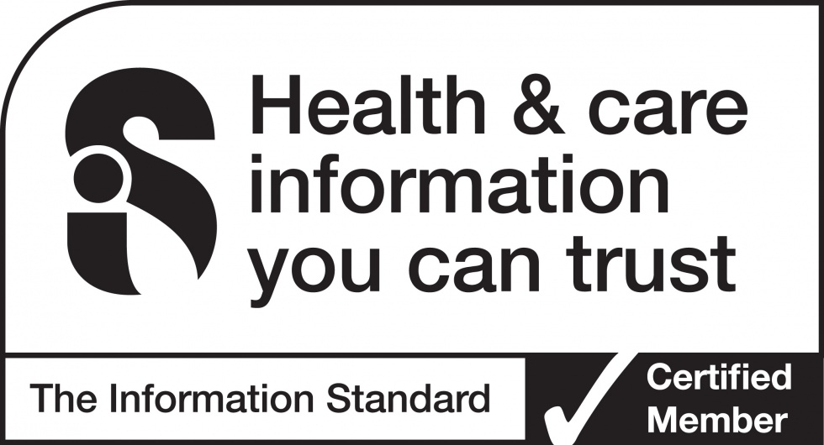

CHR/CT/1030/16.06.14 Version 2

